Sally oketch.

[sally.oketch@womentechsters.org](mailto:sally.oketch@womentechsters.org)

1. **List the processes for current shell**

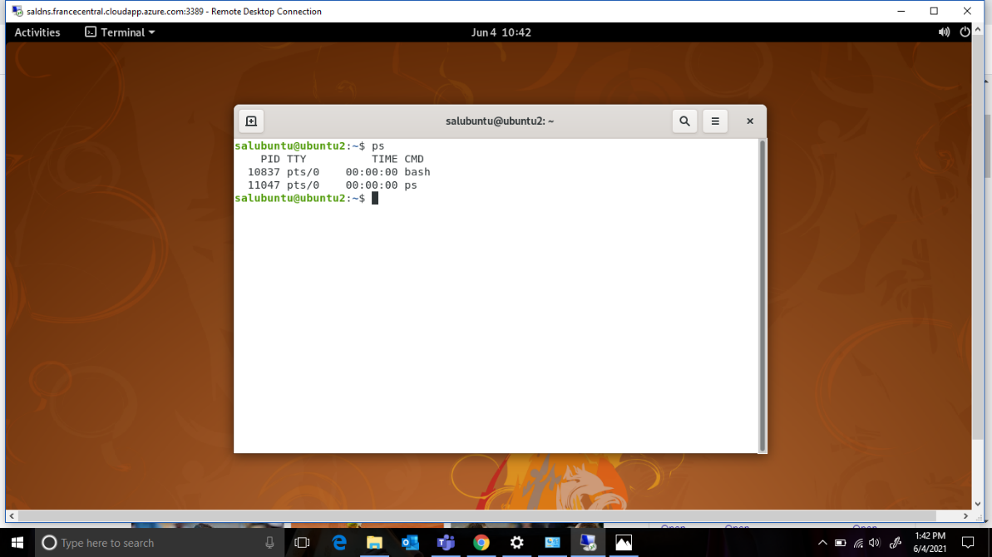

1. **Display information about processes**

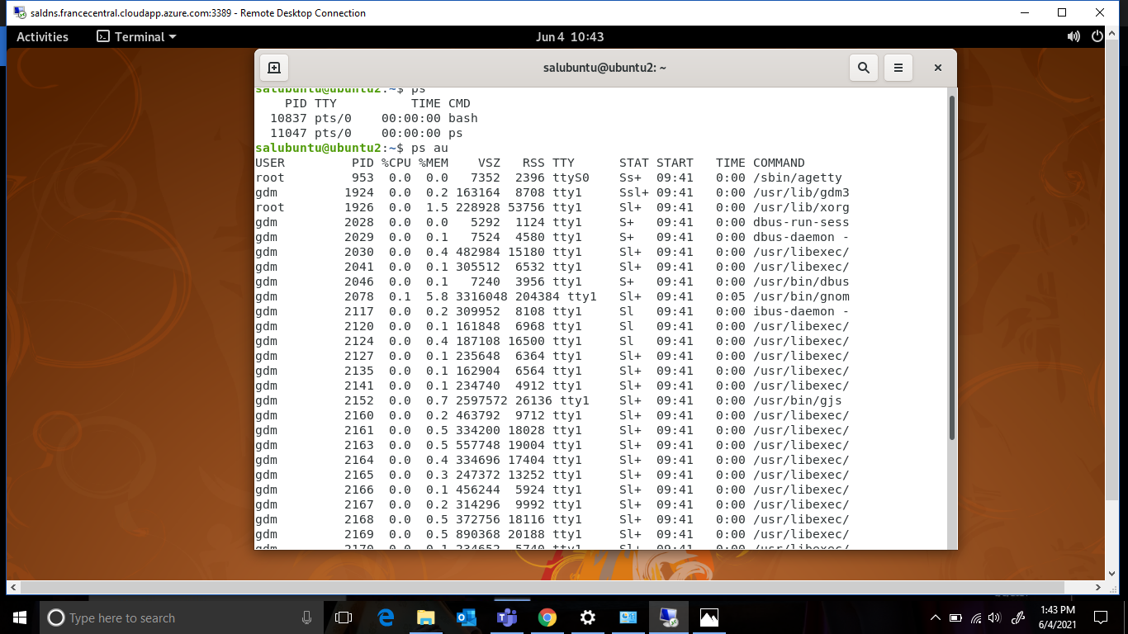

1. **Display the global priority of a process and find out the column that provides**

The column that provides the priority is the **PR** column

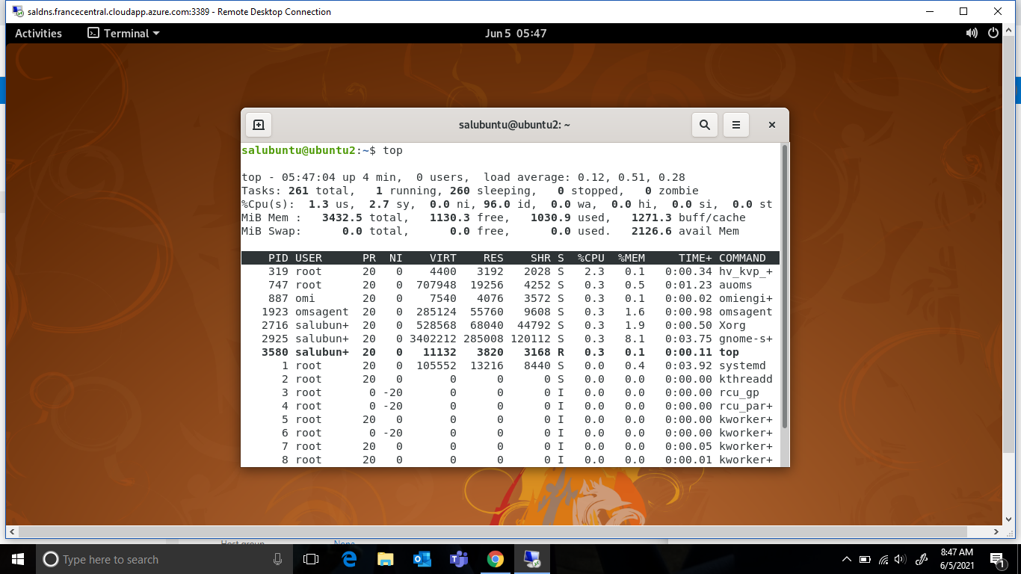

1. **Change the priority of a process with default arguments**

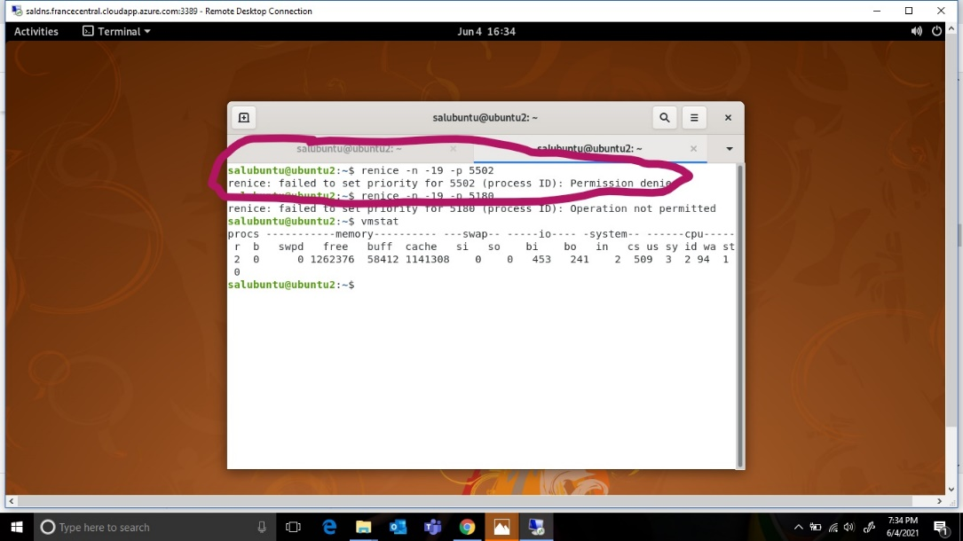

1. **Display virtual memory statistics**

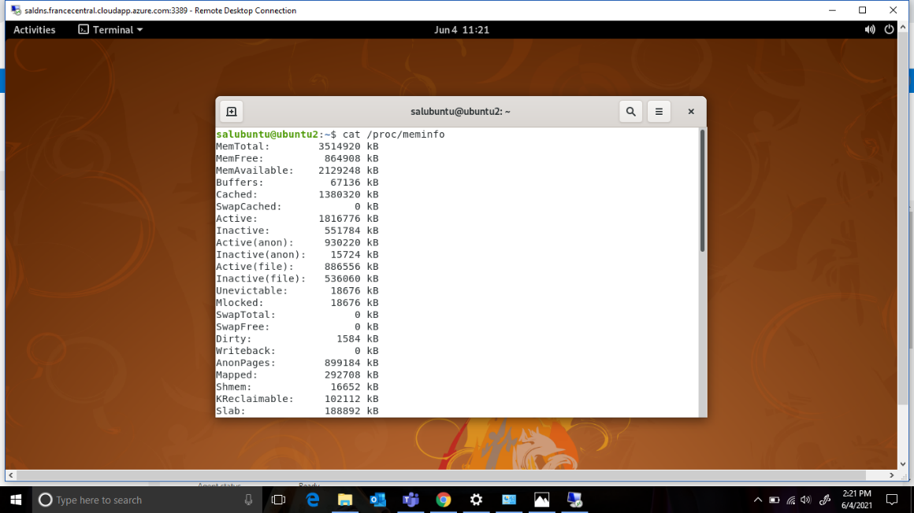

1. **Display system event information**

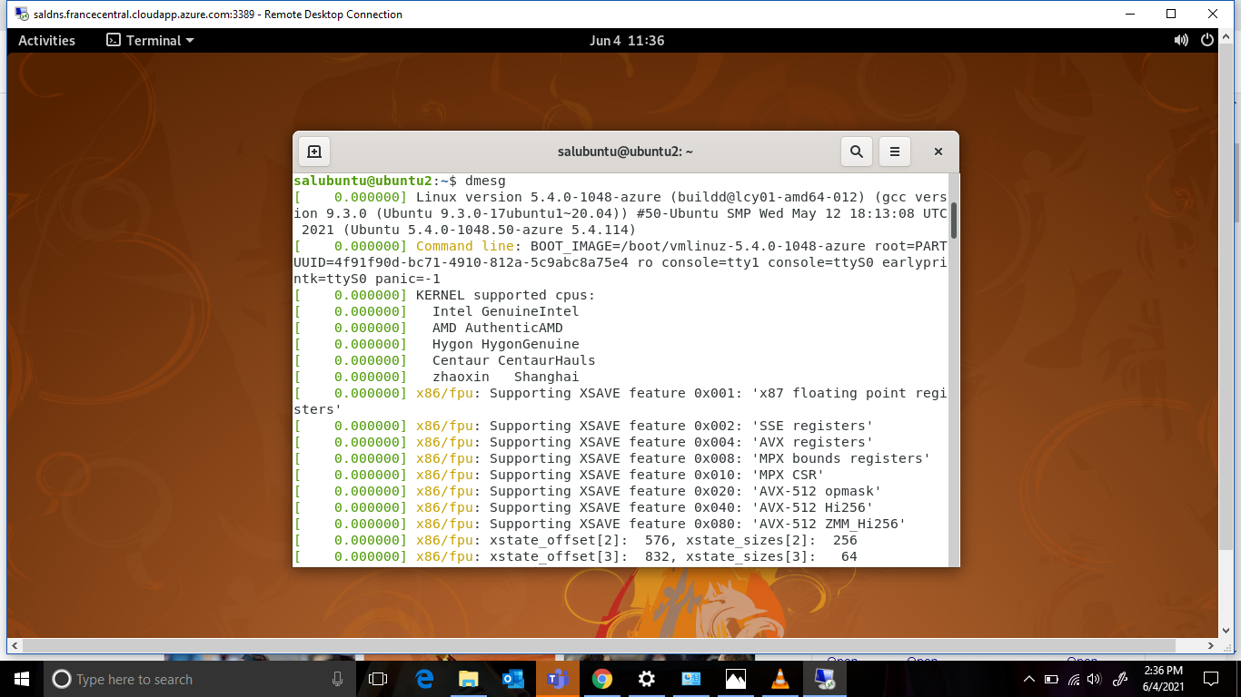

1. **Display swapping statistics**

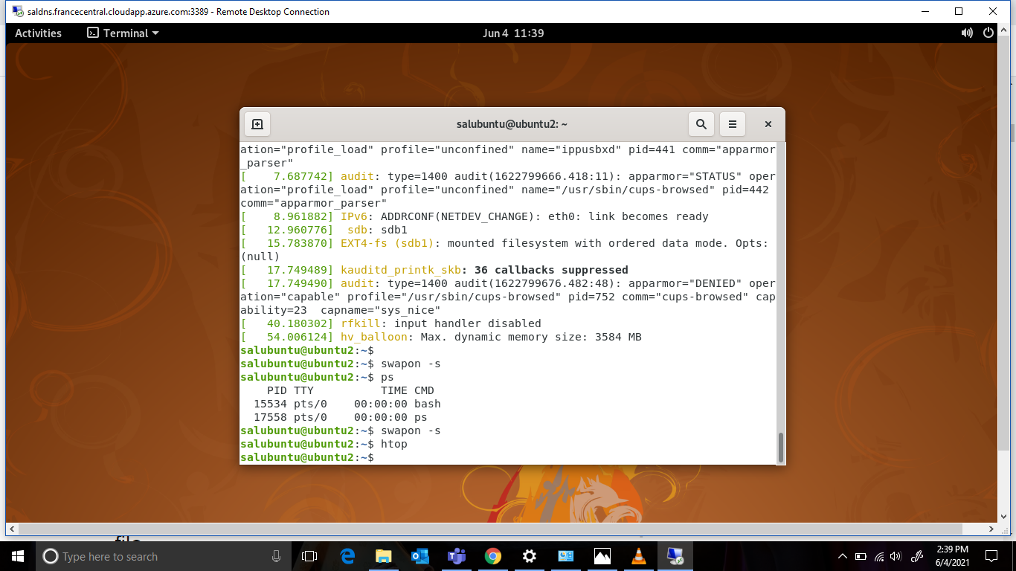

**Htop command brings this window:**

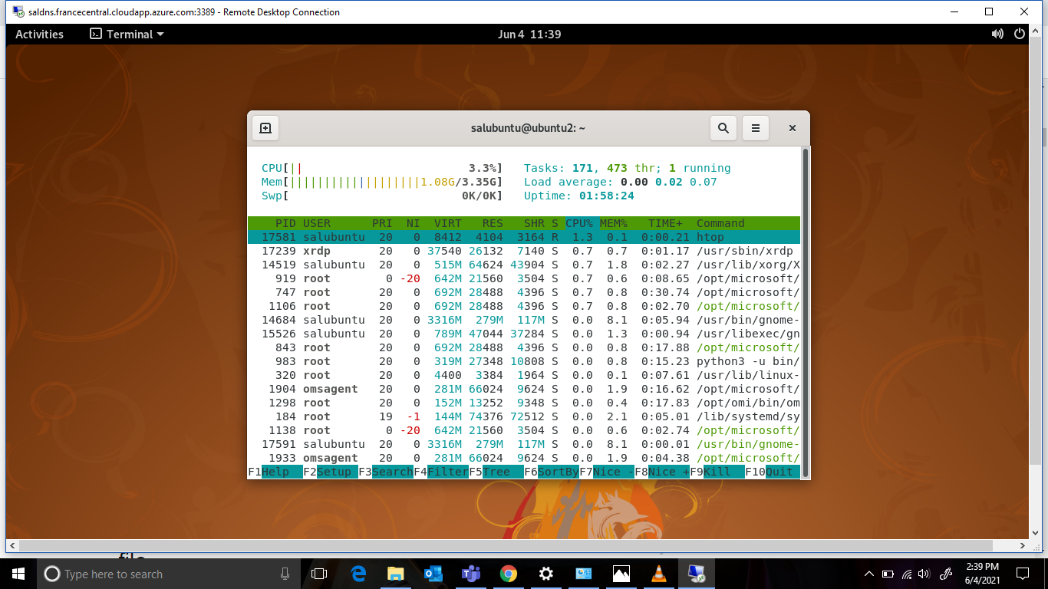

1. **Check file access statistics**

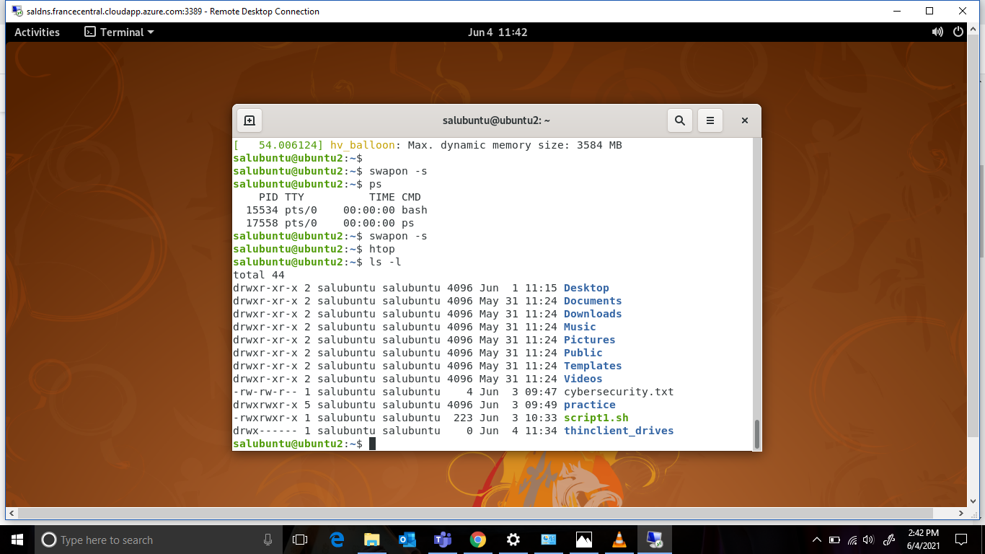

1. **Check buffer activity statistics**

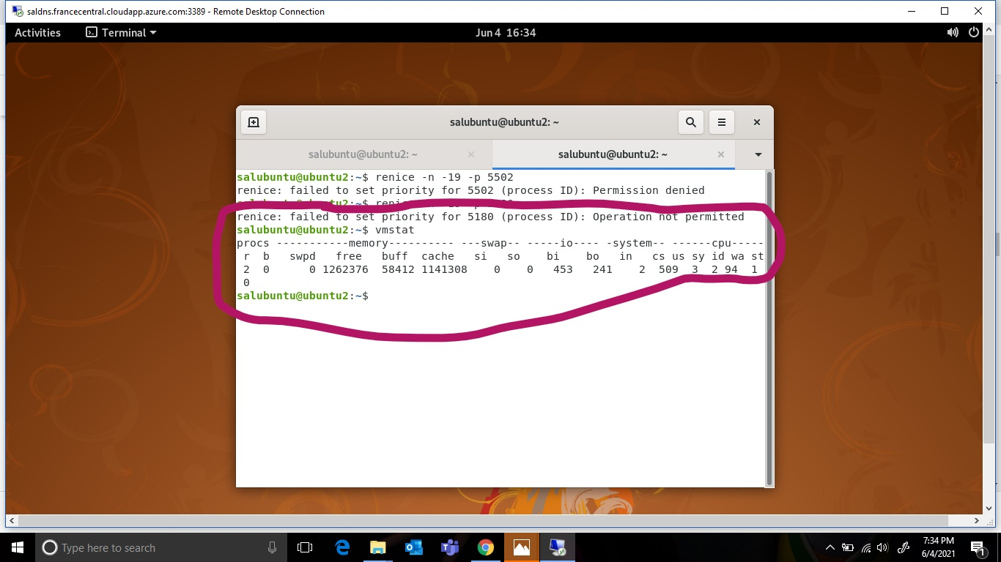

1. **Check disk activity statistics**

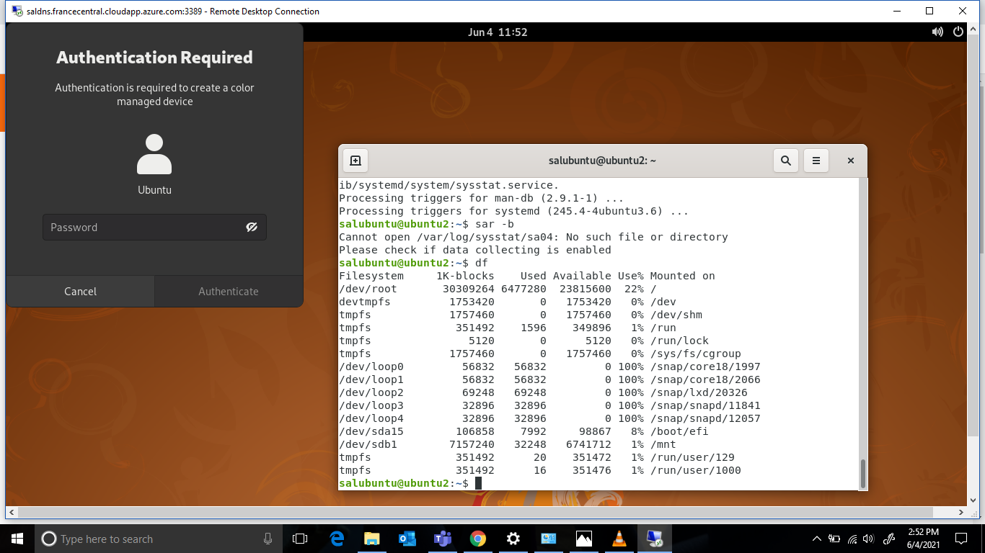

1. **Check Inter process communication statistics**

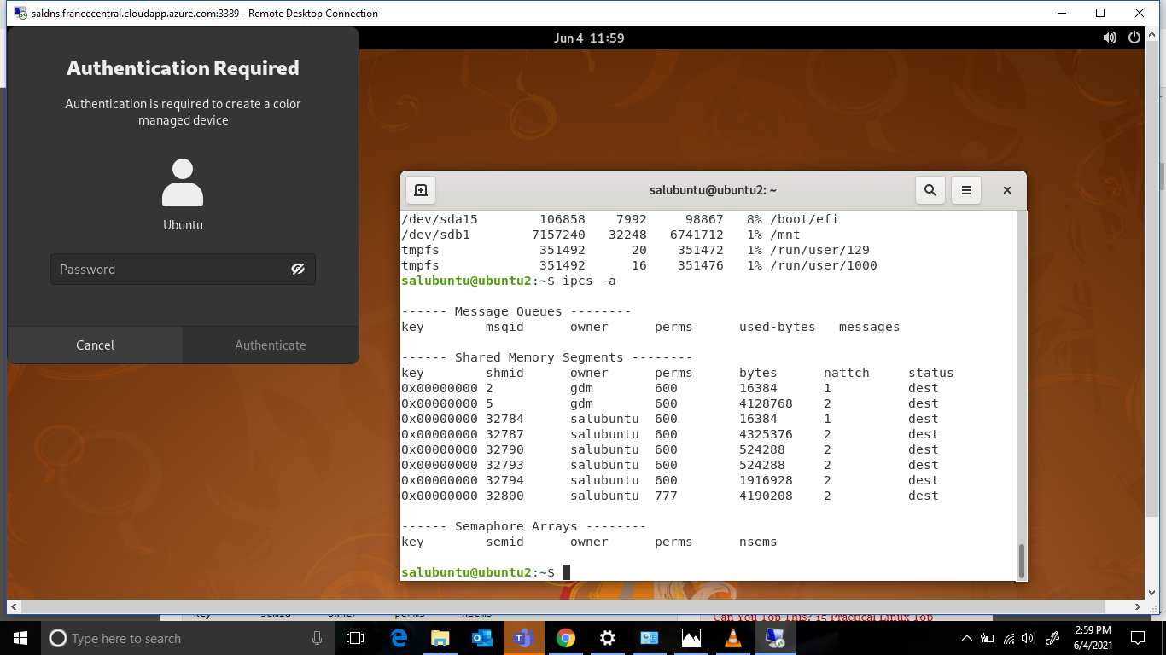

1. **Check unused memory in the server**

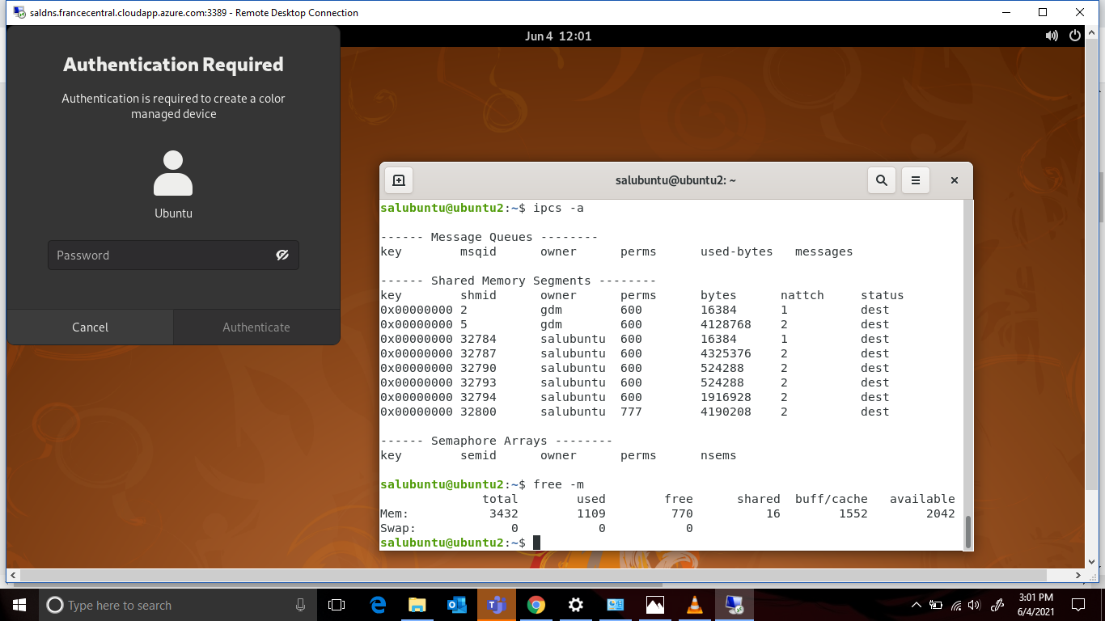

1. **Check swap activities.**

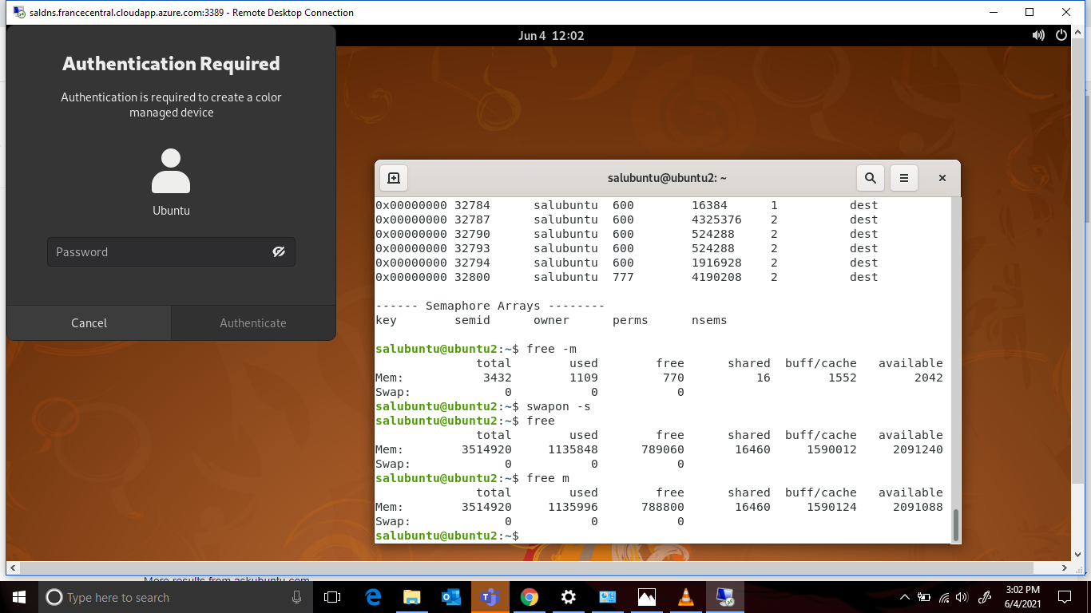

Question 2

1. **Create user account user1 and user2**
2. **Ensure user1 and user2 are password protected**

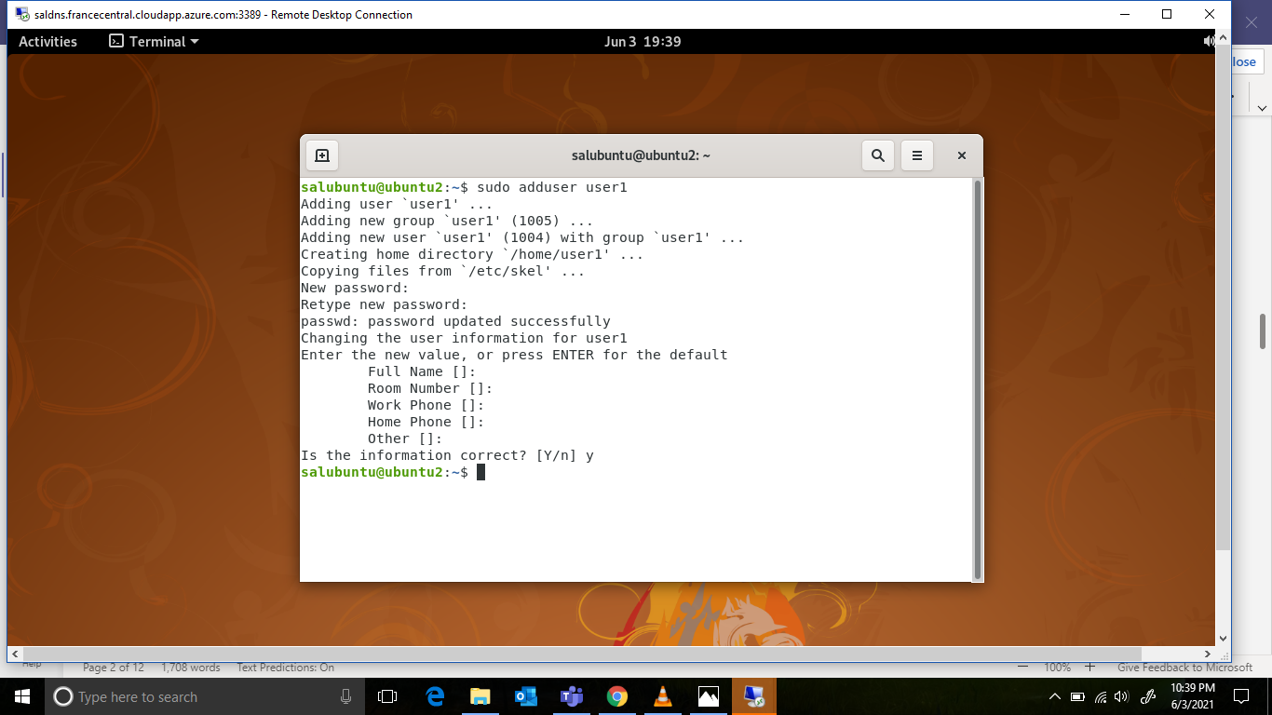

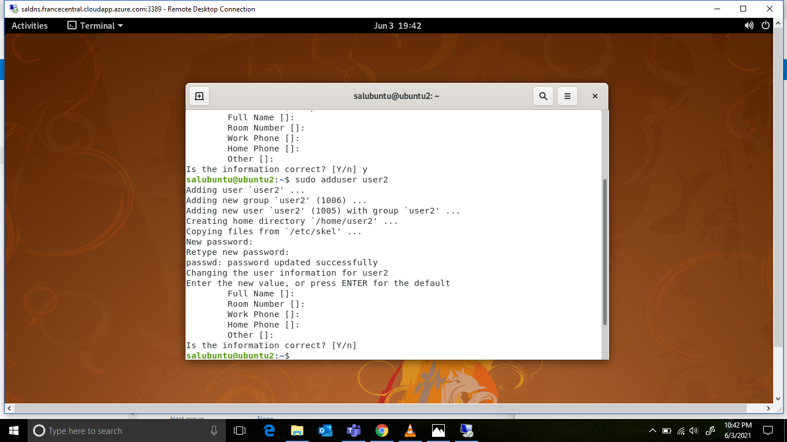

1. **Logout and login as user1**

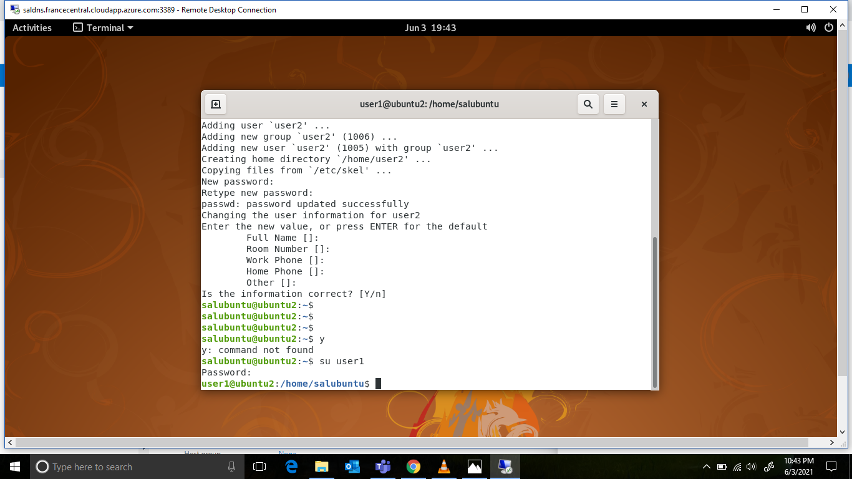

1. **Create a testdir**

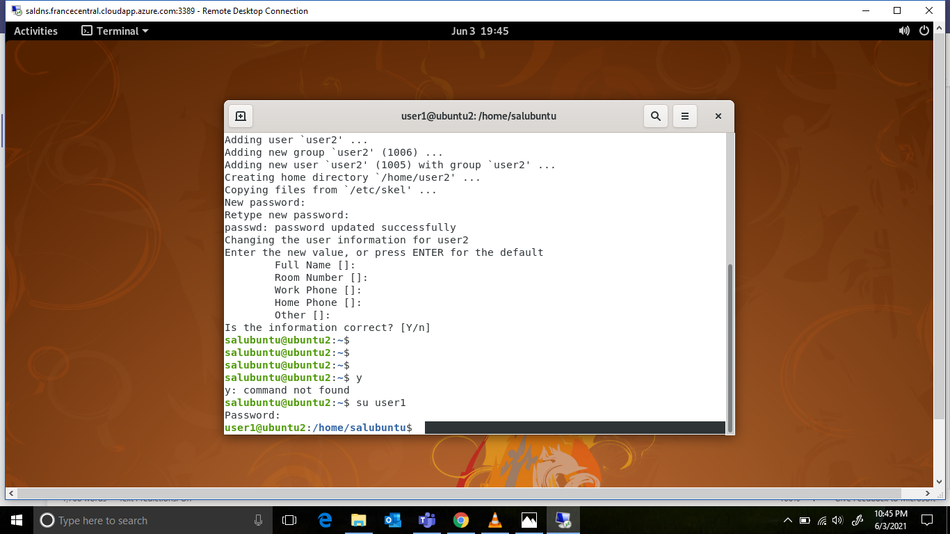

1. **Create a file testfile in testdir**

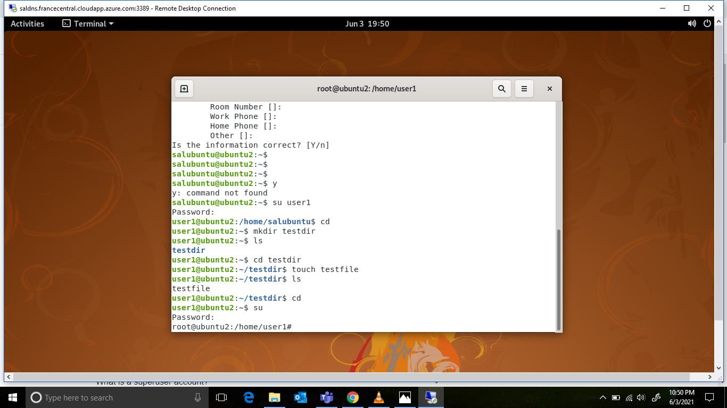

1. **Verify the ownership and the group of the testfile**

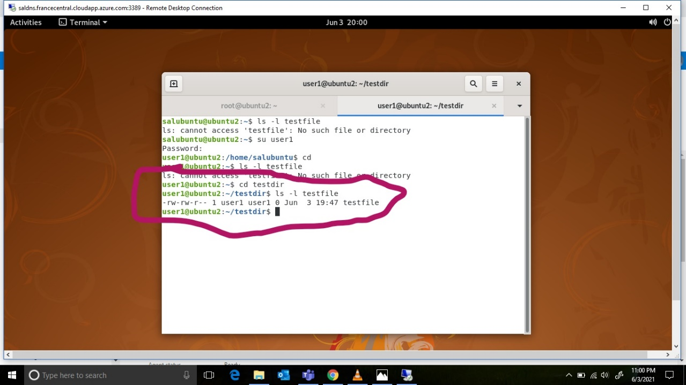

1. **Switch to superuser account**



1. **Create a public directory dir1**

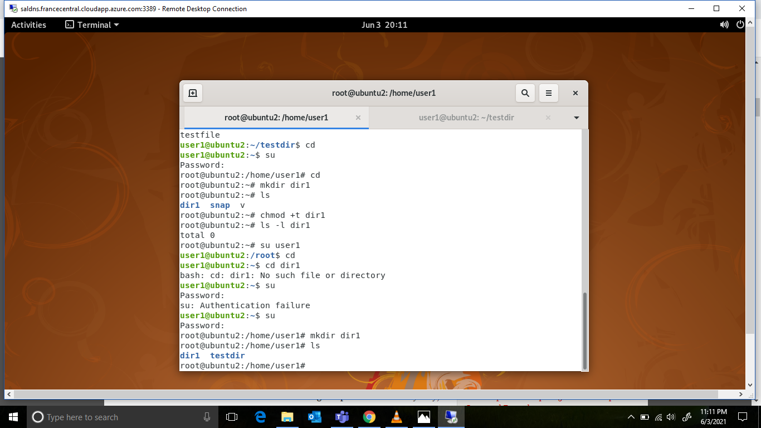

1. **Set stickybit on dir1**

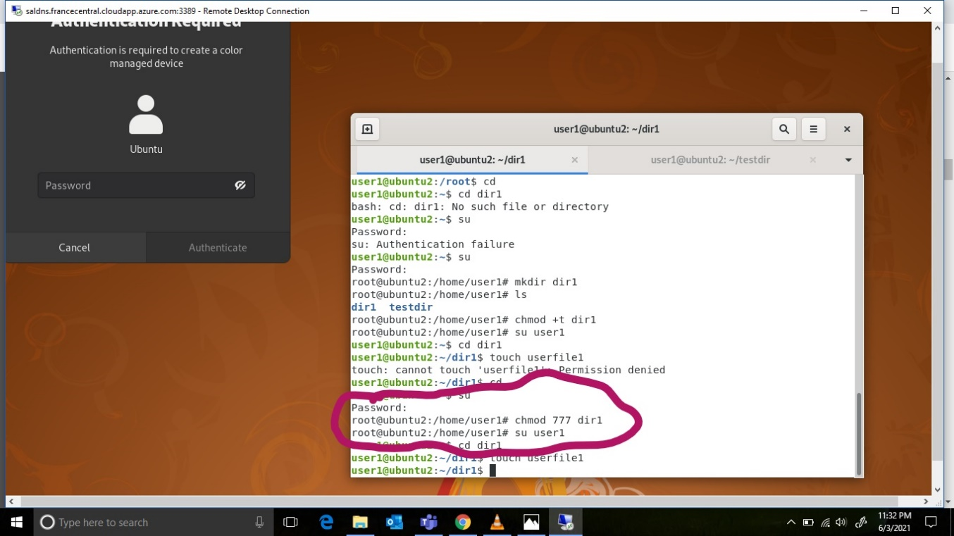

1. **Logout and login as a normal user user1**

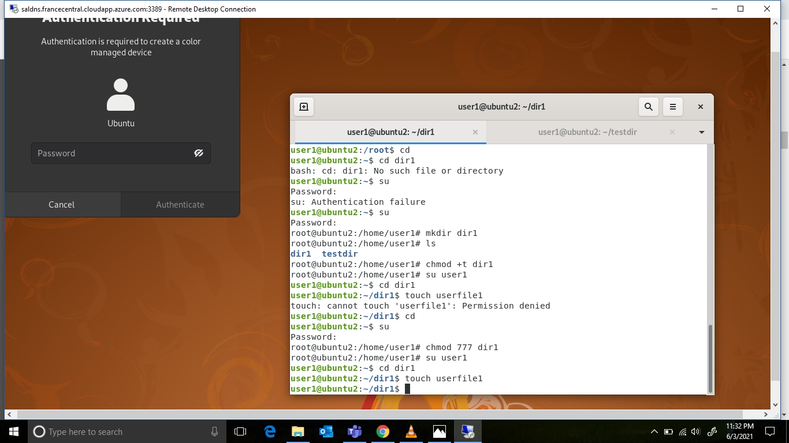

1. **Create a file userfile1 in dir1**

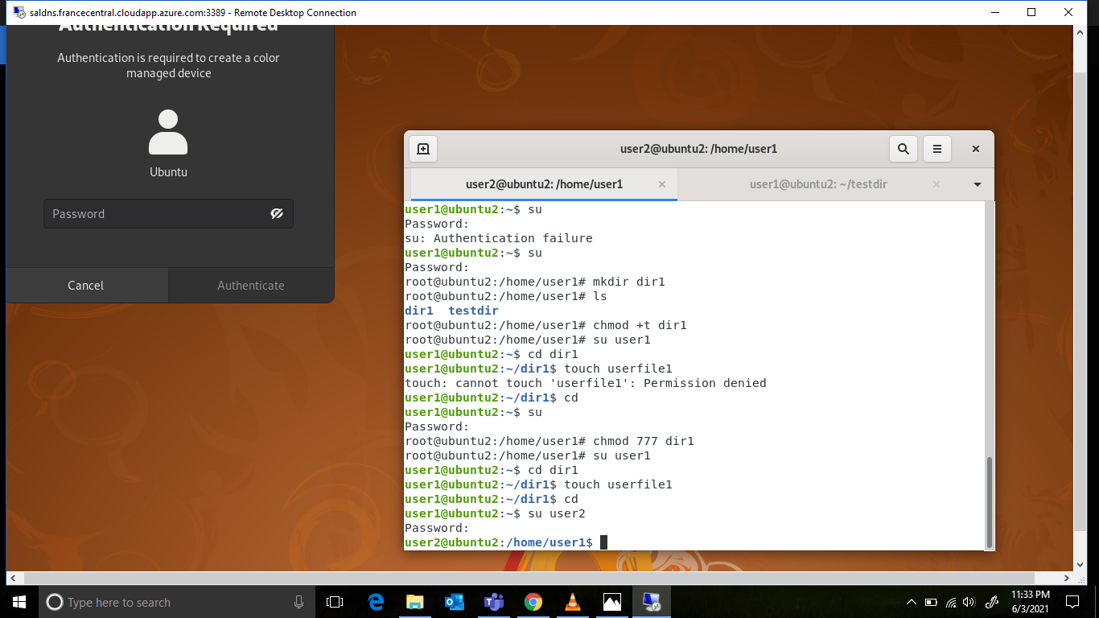

1. **Login as a different user user2**



1. **Try to edit the file**

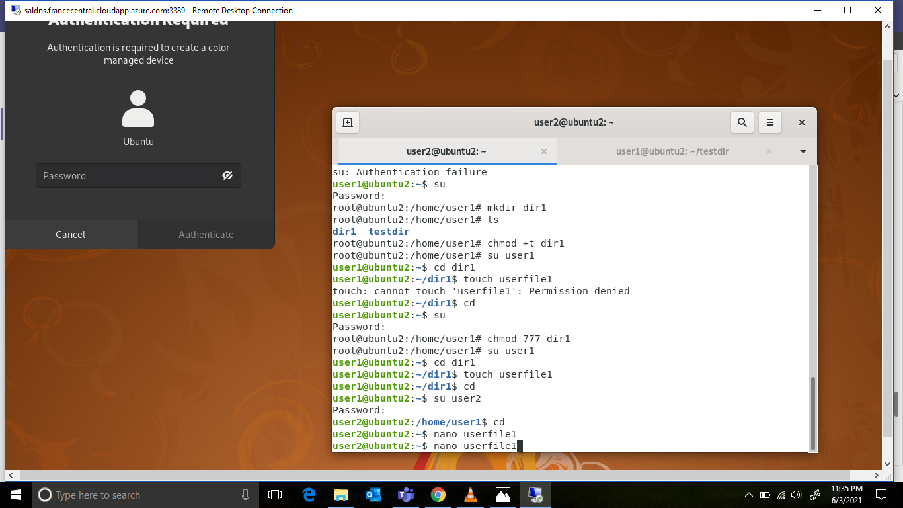

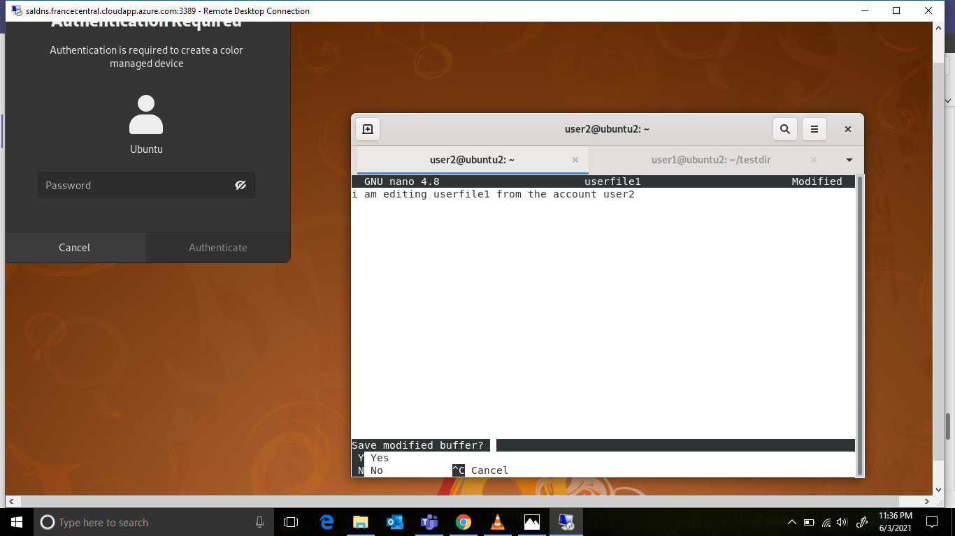

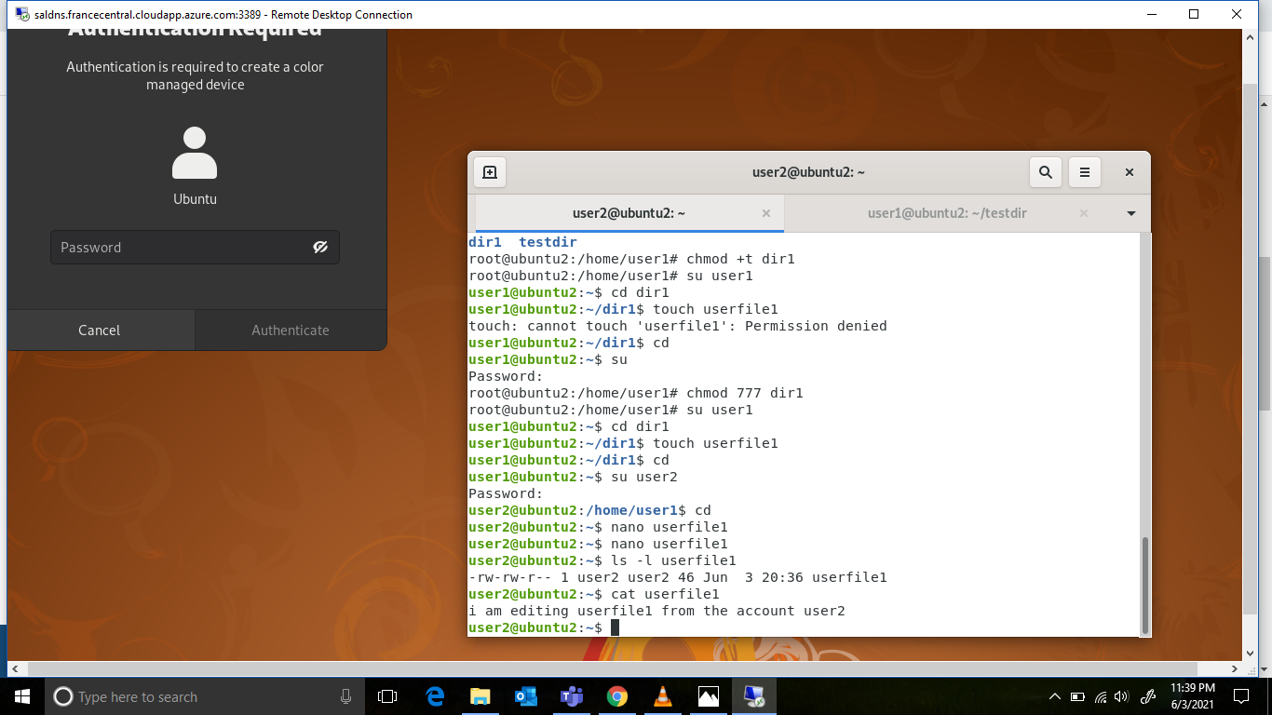

1. **Temporarily disable user logins**

